

**PICTOWORD**

Submitted to: Submitted by:

Dr Kamal deep Ishita Jindal (2110993799)

Kangna (2110993804)

Department Of Computer Science

Chitkara University, Punjab

**TABLE OF CONTENT**

1. Introduction
2. How to play pictoword
3. Flowchart
4. Technology used
5. Conclusion

**INTRODUCTION**

**What is Pictoword?**

Pictoword is a world puzzle game. The game focused into our ability to identify picture provided and make a word out of both pictures that actually makes sense. In Pictoword, the player will “read” two pictures to form a word. The puzzles can be a combination of the pictures (A picture of an ear and ring will form Earring), a [homonym](https://en.wikipedia.org/wiki/Homonym) (A picture of a knight and mare will form Nightmare) or what the pictures sound like (A picture of a taxi and dough will form Tuxedo).

**Why Pictoword?**

Game is challenging and fun world puzzles will enlighten your day. Test your knowledge unscrambling words from pics of historical figures, landmarks, countries etc .Just two pics- Super Fun. The graphic and game design are so soothing and easy to use. This game is suitable for students because they may feel challenged. It can stimulate them to have critical thinking to guess the correct answer from picture.

**HOW TO PLAY PICTOWORD?**

This game is easy to play . You just need to guess picturesand form the word**.** In Pictoword, the player will “read” two pictures to form a word. The puzzles can be a combination of the pictures (A picture of an ear and ring will form Earring), a [homonym](https://en.wikipedia.org/wiki/Homonym) (A picture of a knight and mare will form Nightmare) or what the pictures sound like (A picture of a taxi and dough will form Tuxedo). The user need to guess the given word . If the user thinks the correct one he/she will rewarded score as per else there will be no reward for that question . If the user stucks in between the game he/she can open the instruction page and read according to need. The user can quit the game in between.

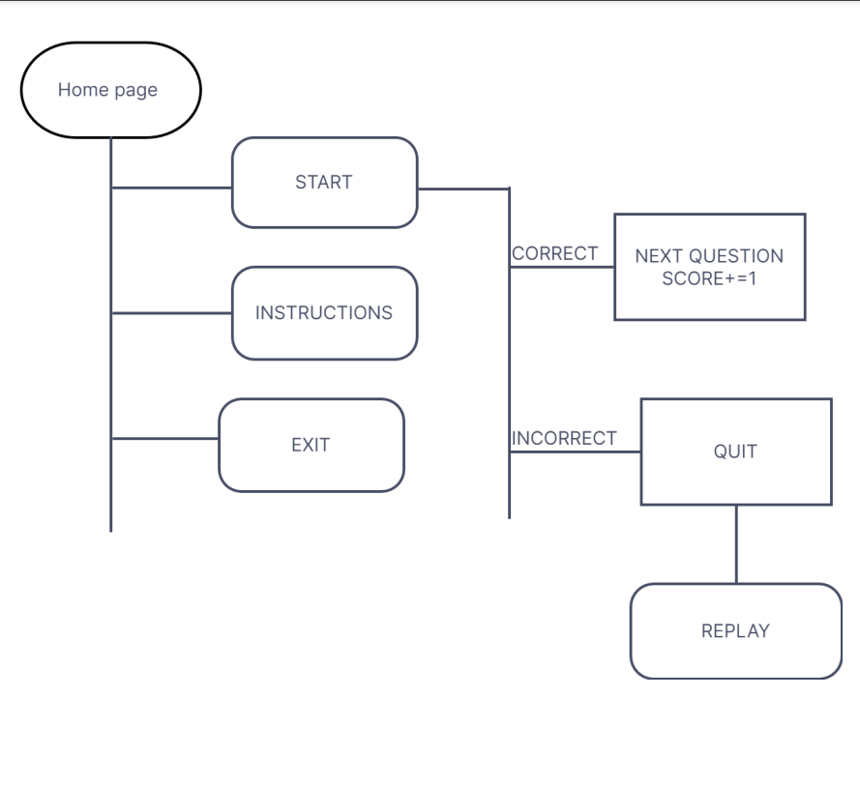

**TECHNOLOGY USED:**

Tkinter

Pygame

Python

**MODULES USED:**

Import random

From tkinter import Tk*

From random import shuffle

Import pygame

Import winsound

Import PIL

Import music

**CONCLUSION**

Pictoword is a great game to ease your daily load because it is fun, most definitely involving and addictive at the same time.

It makes you to be critical thinker.

It can be played with your loved ones thus it does not get boring at some of the other games specific to guessing word from pictures.